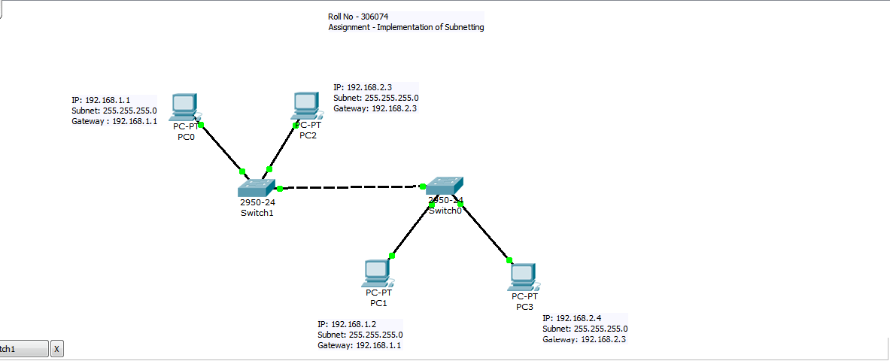

Steps:

1. Add a Switch.
2. Add PC’s.
3. Connect each PC with the switch using straight cable.
4. Wait for all the LED’s to turn green.
5. Assign IP addresses to each PC using IP Configuration menu by clicking on the PC.
6. Check for the connection using simple PDU.
7. Change the last network bit in the IP addresses for 2 PC’s.
8. Check for connections using simple PDU.
9. Add another switch.
10. Connect the switches using cross wire.
11. Remove one PC from each network and connect it to a new switch.
12. Check for connections using simple PDU.

|  |  |  |  |  |  |
| --- | --- | --- | --- | --- | --- |
| **Serial No.** | **Device** | **Interface** | **IP Address** | **Subnet Mask** | **Gateway** |
| 1 | PC0 | Fa0/2 | 192.168.1.1 | 255.255.255.0 | 192.168.1.1 |
| 2 | PC1 | Fa0/2 | 192.168.1.2 | 255.255.255.0 | 192.168.1.1 |
| 3 | PC2 | Fa0/3 | 192.168.2.3 | 255.255.255.0 | 192.168.2.3 |
| 4 | PC3 | Fa0/4 | 192.168.2.4 | 255.255.255.0 | 192.168.2.4 |
| 5 | Switch0 | Fa0/5(Switch1) |  |  |  |
| 6 | Switch1 | Fa0/1(Switch0) |  |  |  |

=====================================================================================

C2950 Boot Loader (C2950-HBOOT-M) Version 12.1(11r)EA1, RELEASE SOFTWARE (fc1)

Compiled Mon 22-Jul-02 18:57 by miwang

Cisco WS-C2950-24 (RC32300) processor (revision C0) with 21039K bytes of memory.

2950-24 starting...

Base ethernet MAC Address: 0001.6394.83B9

Xmodem file system is available.

Initializing Flash...

flashfs[0]: 1 files, 0 directories

flashfs[0]: 0 orphaned files, 0 orphaned directories

flashfs[0]: Total bytes: 64016384

flashfs[0]: Bytes used: 3058048

flashfs[0]: Bytes available: 60958336

flashfs[0]: flashfs fsck took 1 seconds.

...done Initializing Flash.

Boot Sector Filesystem (bs:) installed, fsid: 3

Parameter Block Filesystem (pb:) installed, fsid: 4

Loading "flash:/c2950-i6q4l2-mz.121-22.EA4.bin"...

########################################################################## [OK]

Restricted Rights Legend

Use, duplication, or disclosure by the Government is

subject to restrictions as set forth in subparagraph

(c) of the Commercial Computer Software - Restricted

Rights clause at FAR sec. 52.227-19 and subparagraph

(c) (1) (ii) of the Rights in Technical Data and Computer

Software clause at DFARS sec. 252.227-7013.

cisco Systems, Inc.

170 West Tasman Drive

San Jose, California 95134-1706

Cisco Internetwork Operating System Software

IOS (tm) C2950 Software (C2950-I6Q4L2-M), Version 12.1(22)EA4, RELEASE SOFTWARE(fc1)

Copyright (c) 1986-2005 by cisco Systems, Inc.

Compiled Wed 18-May-05 22:31 by jharirba

Cisco WS-C2950-24 (RC32300) processor (revision C0) with 21039K bytes of memory.

Processor board ID FHK0610Z0WC

Running Standard Image

24 FastEthernet/IEEE 802.3 interface(s)

63488K bytes of flash-simulated non-volatile configuration memory.

Base ethernet MAC Address: 0001.6394.83B9

Motherboard assembly number: 73-5781-09

Power supply part number: 34-0965-01

Motherboard serial number: FOC061004SZ

Power supply serial number: DAB0609127D

Model revision number: C0

Motherboard revision number: A0

Model number: WS-C2950-24

System serial number: FHK0610Z0WC

Cisco Internetwork Operating System Software

IOS (tm) C2950 Software (C2950-I6Q4L2-M), Version 12.1(22)EA4, RELEASE SOFTWARE(fc1)

Copyright (c) 1986-2005 by cisco Systems, Inc.

Compiled Wed 18-May-05 22:31 by jharirba

Press RETURN to get started!

%LINK-5-CHANGED: Interface FastEthernet0/1, changed state to up

%LINEPROTO-5-UPDOWN: Line protocol on Interface FastEthernet0/1, changed state to up

%LINK-5-CHANGED: Interface FastEthernet0/2, changed state to up

%LINEPROTO-5-UPDOWN: Line protocol on Interface FastEthernet0/2, changed state to up

%LINK-5-CHANGED: Interface FastEthernet0/3, changed state to up

%LINEPROTO-5-UPDOWN: Line protocol on Interface FastEthernet0/3, changed state to up

Switch>enable

Switch#configure terminakl

^

% Invalid input detected at '^' marker.

Switch#configure terminal

Enter configuration commands, one per line. End with CNTL/Z.

Switch(config)#fa0/2

^

% Invalid input detected at '^' marker.

Switch(config)#fa0/1

^

% Invalid input detected at '^' marker.

Switch(config)#interface fa0/2

Switch(config-if)#ip address

^

% Invalid input detected at '^' marker.

Switch(config-if)#ip address 192.168.1.2 255.255.255.0

^

% Invalid input detected at '^' marker.

Switch(config-if)#ipaddress

^

Configure terminal

Switch(config-if)#

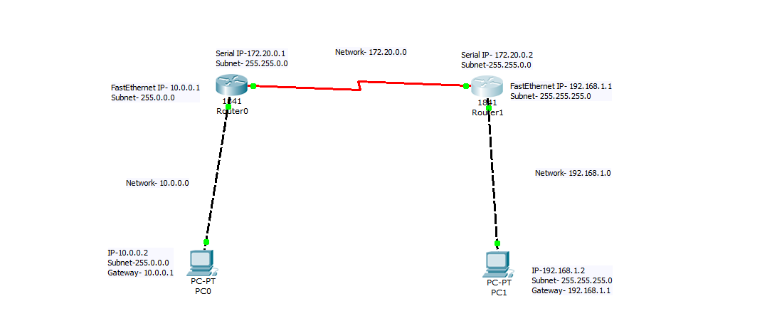4.2

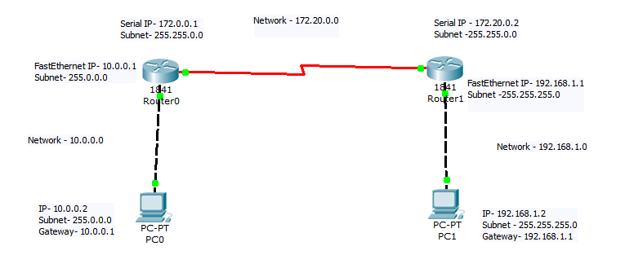4